**PRACTICAL – 4(4.1)**

**AIM:**

**Write one line of Python that takes list a = [1, 4, 9, 16, 25, 36, 49, 64, 81, 100] and makes a new list that has only the even elements of this list in it.**

|  |
| --- |
|  |

**PROGRAM:**

|  |
| --- |
| list = [1, 4, 9, 16, 25, 36, 49, 64, 81, 100]  ans = [i for i in list if i % 2 == 0]  print(ans)  print("\n20DCE019 - Yatharth Chauhan") |

**OUTPUT:**

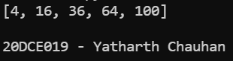

**CONCLUSION:** In this practical I learned the usage of list in python.

**PRACTICAL – 4(4.2)**

**AIM:**

**Write a program to make a two-player Rock-Paper-Scissors game. (Hint: Ask for player plays (using input), compare them, print out a message of congratulations to the winner, and ask if the players want to start a new game) Rules: Rock beats scissors, Scissors beats paper, Paper beats rock**

|  |
| --- |
|  |

**PROGRAM:**

|  |
| --- |
| player1 = input("Enter Player-1 Name: ")  player2 = input("Enter Player-2 Name: ")  p1 = input(  "\n %s, For Player-1: Choose rock, paper or scissors: " % player1)  p2 = input(  "\n %s, For Player-2: choose rock, paper or scissors: s" % player2)  def compare(u1, u2):  if u1 == u2:  return("It's a tie")  elif u1 == 'rock':  if u2 == 'scissors':  return("\nPlayer-1 wins the game")  else:  return("\nPlayer-2 wins the game")  elif u1 == 'scissors':  if u2 == 'paper':  return("\nPlayer-1 win the game")  else:  return("\nPlayer-2 wins the game")  elif u1 == 'paper':  if u2 == 'rock':  return("\nPlayer-1 wins the game")  else:  return("\nPlayer-2 win the game")  else:  return("\nInvalid input")  print(compare(p1, p2))  print("\n20DCE019 - Yatharth Chauhan") |

**OUTPUT:**

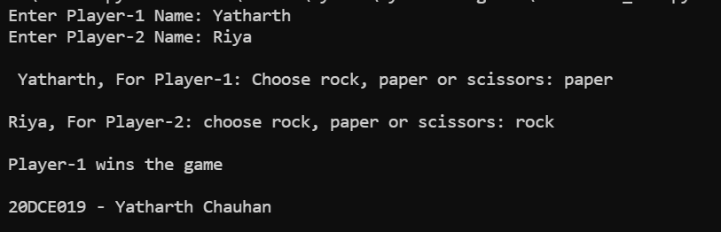

**CONCLUSION:** In this practical we learned the usage of ‘if’’, ‘else’ and ‘elif ‘statement.